

BROWNS RIVER LITTLE LEAGUE SAFETY PLAN

WWW.BROWNSRIVERLITTLELEAGUE.COM

LEAGUE ID: 2450305
EASTERN REGION
VT DISTRICT 3

TABLE OF CONTENTS
1. MISSION STATEMENT................................................................................................ 3
2. LITTLE LEAGUE VOLUNTEER APPLICATION.......................................................... 4
3. LEAGUE OFFICIALS AND CONTACT INFORMATION.............................................. 4
4. SAFETY MANUAL AND PRACTICES......................................................................... 5
5. TRAINING SESSIONS ............................................................................................... 8
6. EMERGENCY PHONE NUMBERS AND PROCEDURES.......................................... 8
7. COMMON LITTLE LEAGUE INJURIES AND RESPONSES...................................... 9
8. COMMUNICABLE DISEASE PROCEDURES ......................................................... 10
9. INCIDENT/INJURY REPORTING PROCEDURE...................................................... 11
10. SNACK SHACK PROCEDURES............................................................................. 12
11. LITTLE LEAGUE FIELD SURVEY........................................................................... 14
12. COVID MITIGATION PLAN………………………………………………………………14

Browns River Little League Mission Statement
The primary mission of Browns River Little League (BRLL) is to teach and provide baseball activities to the youth of Underhill and Jericho in a healthy, safe, enjoyable, and organized manner. A second but equally important goal is to contribute to our community in all other ways that directly serve their best interest.

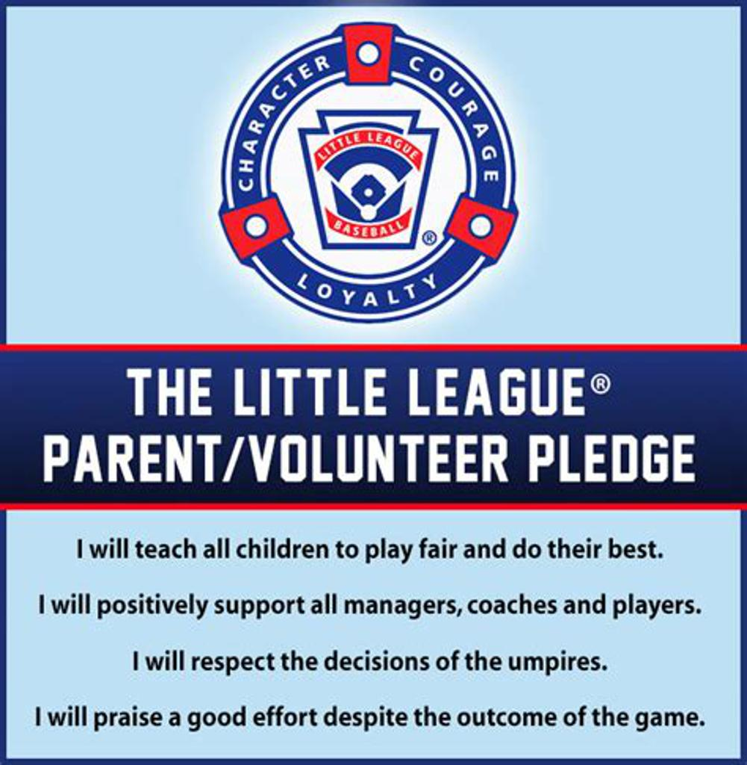

LITTLE LEAGUE VOLUNTEER APPLICATION
The Little League Volunteer Application must be filled out and submitted by all league officials, elected members, managers, coaches, umpires, league coordinators, volunteers or hired workers associated with or provide service to the as well as submitting to a background check through JDP.com.
The League President will consider the volunteer applications confidential and retain the forms for the current year of service. The volunteer application can be found online at https://www.littleleague.org/downloads/volunteer-application/ and/or will be handed out by the league before the season commences.

LEAGUE OFFICIALS AND CONTACT INFORMATION

League President: Casey Knudsen 703-909-9926
League Vice President & Player Agent/Safety Officer: Bill LaPorte 802-363-5253
League Treasurer: David Kupferman 802-260-8732
League Sponsorships/Fundraising: David Marlow 802-309-3521
Coaching Coordinator: Jason Ferreira 802-373-3838
Equipment Coordinator & Coaching Assistant: Chris Dillon 802-598-2506
Softball Coordinator: Merideth Chaudoir 802-999-4622
Farm league Commissioner: Chris VanDenMeiracker 802-735-4880
Umpire Coordinator: Bob Robbins robbins@together.net

SAFETY MANUAL AND PRACTICES

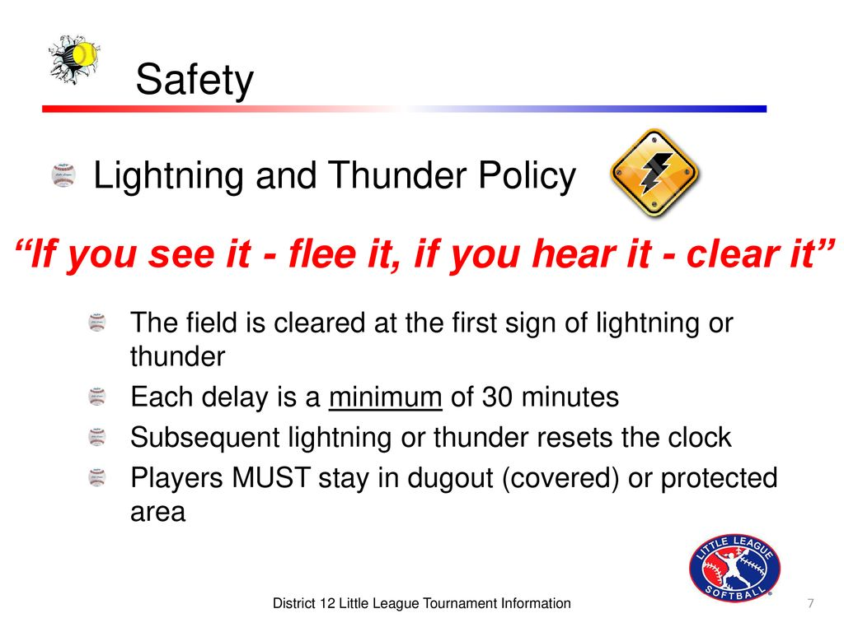
BRLL adheres to the Little League International Policies, Rules and Regulations updated yearly. Specific information can be found at the Little League Website (http://www.littleleague.org).

The Safety Manual is intended to be a common-sense guide to injury prevention and should be adhered to when conducting all BRLL league activities. The items listed below are intended to highlight specific Little League regulations, as well as, rules specific to BRLL.

It is the responsibility of the Safety Officer to annually review and file this safety plan and LL Facility Survey with Little League International. This Safety Manual has been filed and approved by Little League International .

1. The BRLL Safety Manual will be covered with all volunteers and a
copy will be kept inside the Press Box.
2. All Managers, coaches, umpires, league officials, and league volunteers are REQUIRED to submit a background check through JDP.com.
3. Managers and coaches are REQUIRED to have first aid training.
4. Managers and coaches are REQUIRED to have fundamental skills training in baseball and/softball.
5. All managers, coaches, umpires and board members are required to read and adhere to the BRLL Code of Conduct.
6. First aid kits are issued to each team manager and are to be brought to all practices and games. A first aid kit is also located at the pressbox. Managers are responsible for having their first aid kit at all practices and games and maintaining their first aid kit.
7. Each manager is required to have a cell phone on hand for emergency use.
8. Prior to each game or practice the manager(s), coaches and umpire (if game) are required to walk the field and inspect for hazards. Look for damaged fences, equipment, holes, glass, rocks and other foreign objects. Remove or correct the hazard prior to beginning to warm up for the game or practice. Temporary repairs shall be made permanent as soon as practicable. Under no circumstance shall there be play or practice on a field or with equipment that is not safe.
9. Equipment should be inspected, before each use; to be sure it is in good condition and fits properly. Defective equipment is not to be used and shall be immediately discarded.
10. All playing equipment shall be stored off the field of play during games and practices. Acceptable storage locations are within the team dugout or behind the fence.
11. All field maintenance equipment shall be removed from the field prior to starting practice or games. Field maintenance equipment shall be stored in the appropriate areas within fences at each field, and in the pressbox and shed.
12. In the event of lightning or thunder, stop games and practices immediately. All players, managers, and coaches shall take shelter. Dugouts are not considered to be safe shelters from lightning. The field umpire shall determine if the game may resume and the manager will determine if a practice may resume. Do not resume activities until 30 minutes after the last thunder was heard. Use good judgment and err on the side of safety. NEVER ALLOW KIDS OUT ON THE FIELD WITH THUNDER &/or LIGHTNING PRESENT. 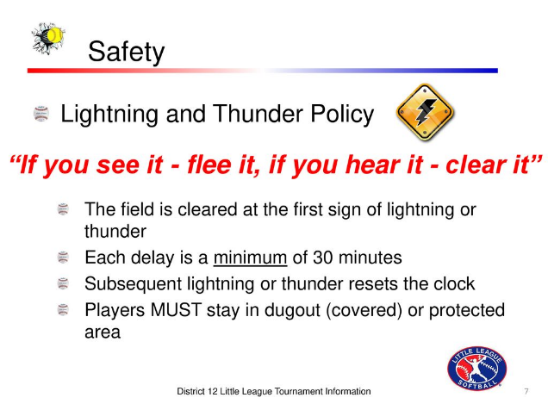
13. Games and practices are not to be held when weather or field conditions are not safe.
14. Don't leave unattended players at a practice or game. Parents or legal guardians should be encouraged to pick up their children promptly at the conclusion of games and practices.
15. Only players, managers, coaches and umpires are permitted on the playing field or in the dugouts during games.
16. During warm-up drills, players should be spaced so that no one, including spectators, is endangered by wild throws or missed catches. Per rule 3.09 Coaches and Managers are not allowed to catch pitchers, including standing at backstop during practice as an informal catcher for batting practice.
17. Male players are encouraged to use protective cups and are REQUIRED to when catching behind the plate.
18. Catchers must wear a Little League approved catcher's helmet, mask, throat guard, long model chest protector, and shin guards for all practices and games.
19. Catchers must wear a Little League approved catcher's helmet, mask, and throat guard while warming up pitchers during practices emergand games and in the “bullpen areas” at the fields.
20. Batters, base runners, and players coaching a base must wear Little League approved protective helmets during all practices and games.
21. Breakaway bases are to be used during all practices and games. Inspect all bases and home plate before use and after plays. Verify that home plate and all bases are set flush.
30. Headfirst slides are not permitted, except when a runner is returning to base.
32. The on-deck position is not permitted (Rule 1.08). The only player permitted to hold a bat during practices and games is the player at bat. Players can only swing in the batter's box.
• Rule 1.08, Notes:”1. The on-deck position is not permitted in Tee Ball, Minor League or Little League (Minors) Division. 2. Only the first batter of each half inning will be allowed outside the dugout between the half-innings in Tee Ball, Minor League or Little League (Majors) Division.

TRAINING SESSIONS
Fundamental skills training for managers and coaches of all baseball and softball divisions (including minors and tee-ball) will be conducted before the start of each season. At least one manager or coach from each team is required to attend.

A Safety Manual Review will occur during these training sessions, as well as First Aid and Concussion Training for managers and coaches.

At least one manager or coach from each team is required to attend.

As part of this training, abuse prevention training shall be addressed with all coaches in accordance with USA Baseball Abuse Awareness Training specifications. If a coach is unable to attend this training session in person, the USA Baseball Abuse Awareness Training information shall be provided to said coach to ensure they are up to speed with the guidelines.

EMERGENCY PHONE NUMBERS AND PROCEDURES
1. Immediately stop game/practice to assist an injured person.
2. If necessary, immediately Call 911, and follow their instructions
3. Immediately appoint someone to go to the field entrance and look for emergency responders. Ensure that the path to the injured party is clear. Provide clear directions to the exact location of the injured party. This saves valuable time. Remember every minute counts.
4. Provide, or assist in obtaining, medical attention for those who require it.
5. Look for signs of injury.
6. Listen to the injured describe what happened and what hurts.
7. Examine the injured area for signs of swelling or broken bone(s).
8. Ask for help if you are not sure of proper procedures, such as CPR.
9. Do not, at any time, administer any kind of medication, including over the counter medicines such as Tylenol or Advil. This is the parent's/guardian's responsibility.
10. If injury involves the neck or back, DO NOT move the victim unless absolutely necessary. Wait for paramedics.

Table 2. Emergency Numbers
Agency | Number
Police Emergency | 911
Fire Emergency | 911
Ambulance Emergency | 911
Poison Control Center | 800-222-1222
Police Non-emergency | 802-878-7111

COMMON LITTLE LEAGUE INJURIES AND RESPONSES:

BASIC ISSUES WITH BASEBALL / SOFTBALL
Injuries commonly seen in baseball/softball such as contusions, muscle pulls and strains, over use injuries, sprains, fractures, injuries to small joints, facial injuries, injuries to teeth, eye injuries, insect bites and stings, and heat illnesses will be addressed as follows per the first aid clinics outline:
- Ensure coaches/managers stop play to protect player from further injury
- Coaches/managers need to assess players ability to breath, check their pulse if applicable, and assess the severity of the injury to determine next steps.
- If necessary, contact 911 immediately if special expertise is needed in addressing the injury.
- If 911 is not needed after the injury is determined to be minor, determine if player can be moved to a safe location to further examine the injury.
- Once assessed, Coach/Manager should work with players parent to administer the necessary treatment and determine next steps (coach/manager shall suggest to player’s parent(s) that they follow up with a medical professional).
- Finally, the Coach/Manager shall receive medical release from parent.

COMMUNICABLE DISEASE PROCEDURES
While risk of one athlete infecting another with HIV/AIDS during competition is close to non-existent, there is a remote risk that other blood born infectious diseases can be transmitted. For example, Hepatitis B can be present in blood as well as in other body fluids. Procedures for reducing the potential for transmission of these infectious agents should include, but not be limited to, the following:

1. The bleeding must be stopped, the open wound covered and if there is an excessive amount of blood on the uniform it must be changed before the athlete may participate.
2. Routine use of gloves or other precautions to prevent skin and mucous-membrane exposure when contact with blood or other body fluids is anticipated.
3. Immediately wash hands and other skin surfaces if contaminated (in contact) with blood or other body fluids. Wash hands immediately after removing gloves.
4. Clean all contaminated surfaces and equipment with an appropriate disinfectant before competition resumes.
5. Practice proper disposal procedures to prevent injuries caused by needles, scalpels and other sharp instruments or devices.
6. Although saliva has not been implicated in HIV transmission, to minimize the need for emergency mouth-to-mouth resuscitation, mouthpieces, resuscitation bags, or other ventilation devices should be available for use.
7. Athletic trainers/coaches with bleeding or oozing skin conditions should refrain from all direct athletic care until the condition resolves.
8. Contaminated towels should be properly disposed of/disinfected.
9. Follow acceptable guidelines in the immediate control of bleeding and when handling bloody dressings, mouth guards and other articles containing body fluids.

INCIDENT/INJURY REPORTING PROCEDURE
1. What to Report - Any incident/injury for which any player manager, coach, umpire or volunteer receives medical treatment and/or first aid must be reported to the Safety Officer (SO)

2. When to Report - All such incidents described above must be reported to Safety Officer (SO) within 48 hours of the incident. Prompt verbal notification to the SO is advised as soon as possible. REPORT THE FOLLOWING:

• Name and phone number of the individuals involved
• Date, time and location of the incident
• As detailed a description of the incident as possible
• Preliminary estimate of the extent of injuries
• Name and phone number of person reporting the incident

3. Safety Officer’s Responsibility with Respect to Injuries and Safety:
1. Within 48 hours of receiving the incident report, the Safety Officer (SO) will contact the injured parties or their parents (or legal guardians) and:
a. Verify and clarify all necessary information
b. Obtain any other information deemed necessary
c. Check on the status of the injured party
2. In the event that the injured party required other medical treatment (e.g. Emergency Room visit, doctor's visit) the SO is to:
a. Advise the parents or guardian of the Little League's insurance coverage and the provisions for submitting claims
b. Submit an Accident Claim Form to Little League International within 20 days of the accident (Appendix 9).
c. Follow-up, as necessary, depending on the extent of the injuries.
3. Managers are to track “near misses” and record the details and provide in writing to the Safety Officer within 48 hours of the incident. The Safety Officer will track the near misses and share the database with District Staff as required.
4. It is the responsibility of the Safety Officer to conduct the Annual Little League Facility Survey and submit it to Little League International.
5. It is the responsibility of the Safety Officer to distribute ASAP News newsletters and/or reports to league officials and members as necessary.

4. Parents Responsibility with Respect to Injuries/Safety and Player Return to Activity:
1. In the event of Professional Medical Treatment (e.g., Emergency Room visit, doctor’s visit) it is the responsibility of the parent to notify the Safety Officer and Team Manager of medical restrictions relating to the injury.
2. In the event of a diagnosis of concussion, the player is restricted from ANY activity until written documentation is obtained from a health care professional clearing the injured party to resume full activity and a copy is provided to the Safety Officer.

ACCIDENT REPORT FORMS ARE LOCATED HERE: https://www.littleleague.org/downloads/accident-claim-form/

SNACK SHACK PROCEDURES

- BRLL Snack Shack volunteers will practice safe food handling at all times.
- Children under 18 are not permitted to cook on the grill.
- Volunteers will clean the snack shack before the season starts, and thoroughly at season’s end. All food will be removed from Snack Shack after the season.
- All volunteers will follow food safety guidelines below:

FOOD PREP
1. Gloves will be provided - use gloves when handling food.
2.Burgers and hot dogs should be cooked to proper temp on the grill, when grill is in use.
3. Change gloves after handling money.
4. In lieu of a handsink - sanitize hands often
5. Foil wrappers for the burgers and dogs are on the grill

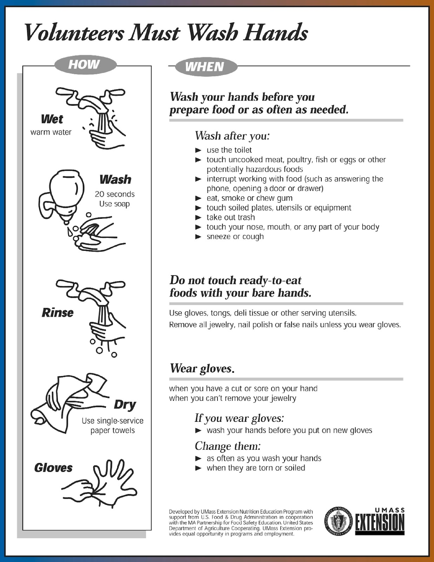

LITTLE LEAGUE FIELD SURVEY
It is the responsibility of the Safety Officer to conduct an annual survey of BRLL’S Little League Facilities and submit a Little League Facilities Survey to Little League International. Safety Officer shall submit survey through the Little League Data Center.

